OBJECTIVE Q’s ANSWERS (13/17/18)

The distribution of account balances varies significantly across geographic regions. Regions with a higher number of customers tend to contribute a larger share of the total balance. However, average balance per customer differs across regions, indicating variations in customer wealth and banking behavior. This suggests reflects regional economic differences and customer income patterns.
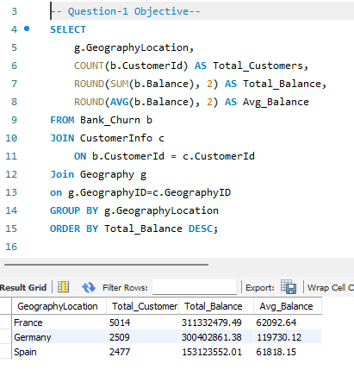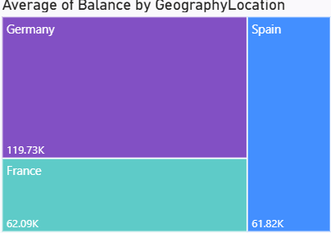
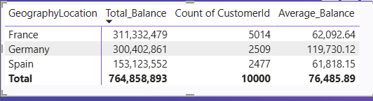

Using the bank date of joining (Bank DOJ), customers who joined during the last quarter of the year (October–December) were filtered. Among these customers, the top five were identified based on their estimated salary. These customers represent the highest income segment acquired during the last quarter and can be targeted for premium and wealth management services.
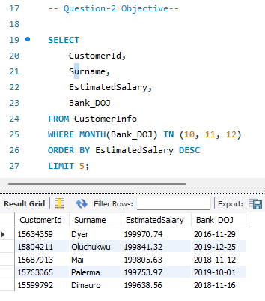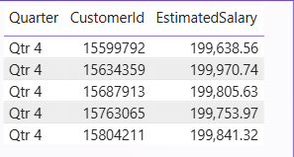

The average number of products used by customers who possess a credit card was calculated by filtering customers with the credit card indicator enabled. The result shows that credit card holders tend to use multiple banking products on average (1.53), indicating a higher level of engagement with the bank’s offerings.
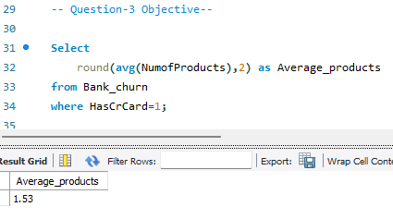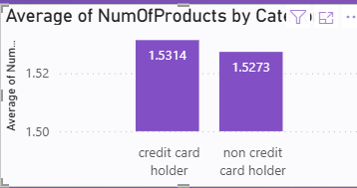

The churn rate by gender was calculated for the most recent year available in the dataset using the bank date of joining (Bank DOJ). The analysis shows that churn behavior differs across gender groups, showing female has higher churn rate which indicating that gender-specific factors may influence customer retention. These insights can help the bank design targeted retention strategies for different customer segments.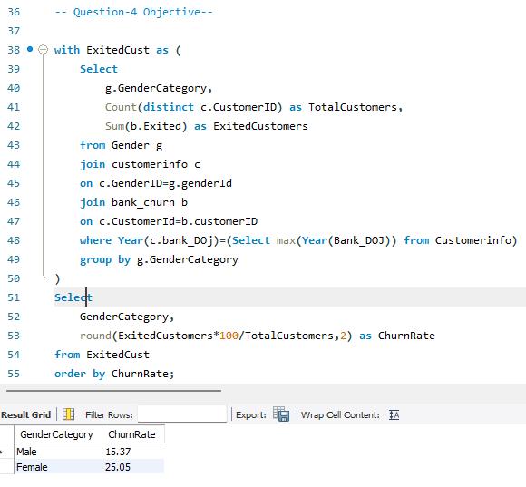 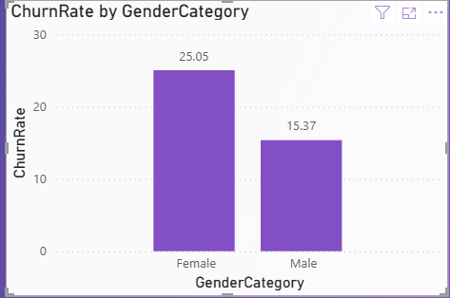

The average credit score was compared between customers who exited the bank and those who remained. The analysis shows a clear difference in average credit scores across the two groups, with retained customers generally having a higher average credit score. This indicates that customers with lower credit scores may have a higher likelihood of churn, making credit score a potentially important factor in customer retention strategies.
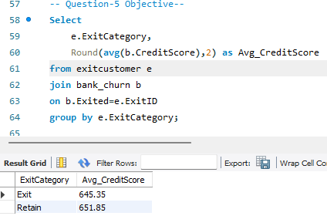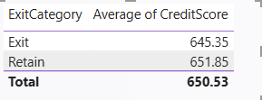
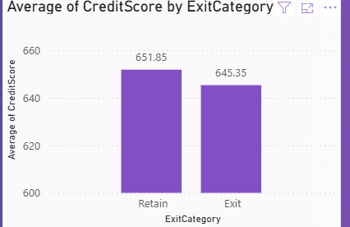

The average estimated salary was calculated for each gender and compared with the number of active accounts. The results show that females have a higher average estimated salary, while the number of active accounts varies across genders (males having more). This suggests that higher income does not always directly translate into higher customer activity, indicating that engagement strategies should not rely solely on income levels.
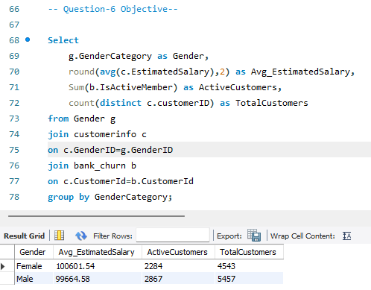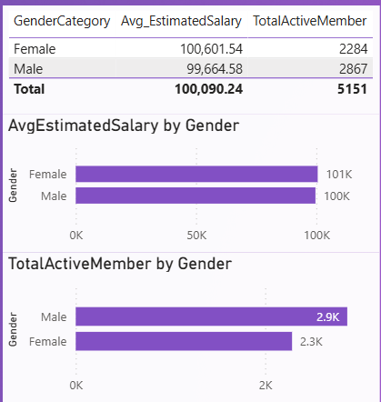

Customers were segmented into different credit score categories to analyze exit behavior across risk profiles. The analysis shows that customers in lower credit score segments exhibit a higher exit rate compared to those in higher credit score categories. This indicates that customers with weaker credit profiles are more likely to churn, highlighting the importance of targeted retention strategies for high-risk credit segments.
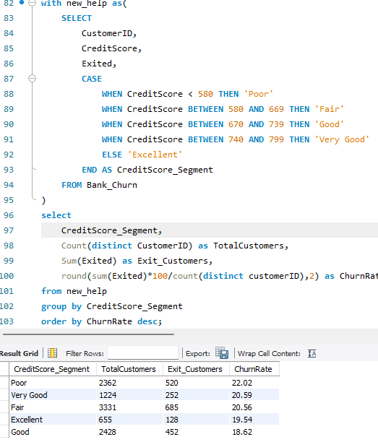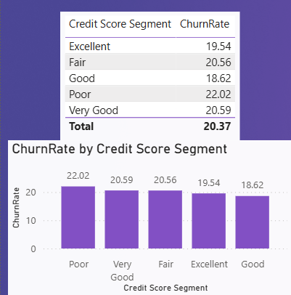

Active customers with a tenure greater than five years were filtered and grouped by geographic region. The analysis shows that France region has the highest number of long-tenured active customers, indicating stronger customer loyalty and retention in the region. This suggests that regional factors may play a role in sustaining long-term customer relationships.
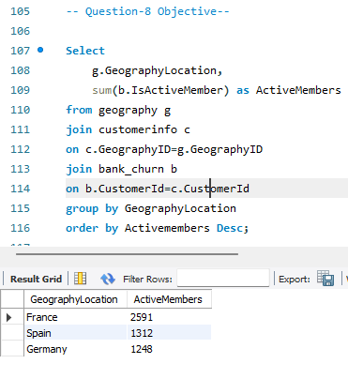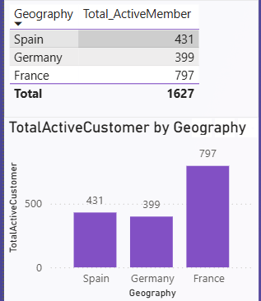

To assess the impact of credit card ownership on customer churn, customers were grouped based on whether they possessed a credit card. The churn rate was calculated for each group. The results indicate a noticeable difference in churn behavior between credit card holders and non-holders, suggesting that credit card ownership influences customer retention. Customers with credit cards generally show higher engagement with the bank, which may contribute to lower churn rate.
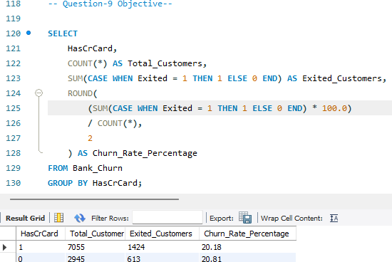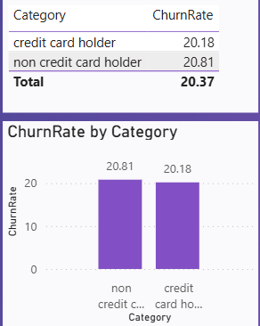

Among customers who exited the bank, the most common number of products used was identified by analyzing the frequency distribution of products held by churned customers. The results indicate that product count 1 is most prevalent among exited customers, suggesting that customers with limited product engagement are more likely to churn. This highlights the importance of cross-selling and increasing product adoption to improve retention.
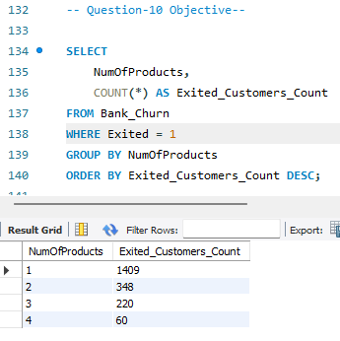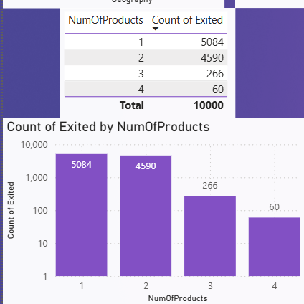

The customer joining trend was analyzed over time using the bank date of joining (Bank_DOJ). A year-wise analysis shows how customer acquisition has evolved over different years, indicating periods of growth. Additionally, a month-wise analysis was performed to identify seasonal patterns. The results suggest that customer onboarding exhibits noticeable monthly variations, indicating possible seasonality in customer acquisition.
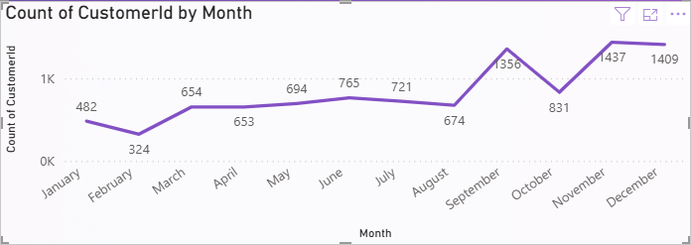
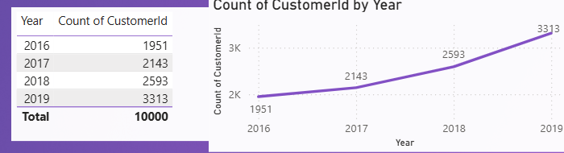
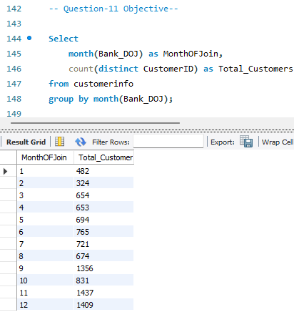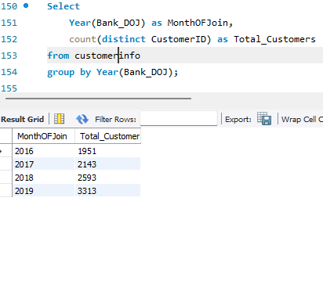

The relationship between the number of products and account balance was analyzed for customers who have exited the bank. The results indicate that exited customers with a lower number of products tend to have lower average balances, while variations in balance are observed as the number of products increases. This suggests that customers with limited product engagement and lower balances may be more prone to churn, emphasizing the importance of cross-selling and product bundling strategies.
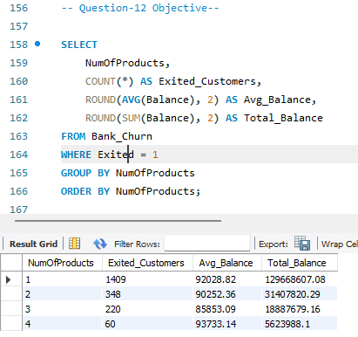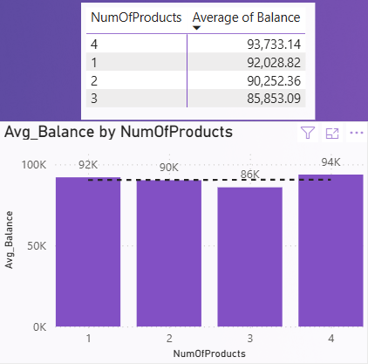

After filtering retained customers and applying the IQR method, no balance values were found outside the lower and upper bounds. This indicates that retained customers’ balances are relatively well-distributed, with no statistically significant outliers under the standard 1.5×IQR criterion.
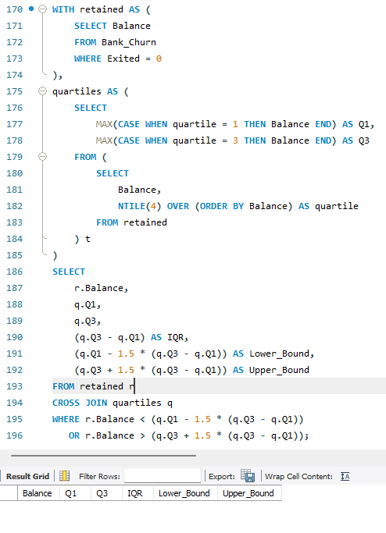

The dataset consists of seven tables. Among which the two table seems primary tables are: CustomerInfo and Bank_Churn. Both tables contain a combination of numerical, categorical, and date-related attributes. Other five tables in the dataset that consists exclusively of categorical variables. Having, categorical information such as gender, geography, credit card ownership, and Active Status and Exit Status is represented through encoded columns within the main table which are linked to categorical tables : geography, ActiveCustomer, ExitCustomer, Gender, CreditCard.

The gender-wise average estimated salary was calculated for each geographic region, and genders were ranked within each geography based on the average salary value. The analysis highlights variations in income levels across genders within different regions. In several geographies, one gender consistently ranks higher in terms of average estimated salary, indicating potential regional and demographic income disparities.
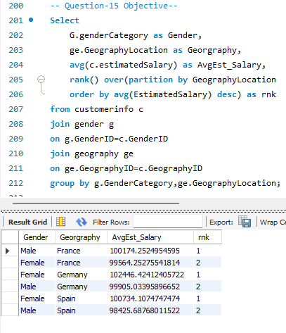

Exited customers were grouped into predefined age brackets to analyze their average tenure with the bank. The results show differences in average tenure across age groups, indicating that customers in certain age bracket (30-50) tend to remain with the bank longer before exiting. This insight can help the bank design age-specific retention strategies and tailor engagement initiatives for different customer segments.
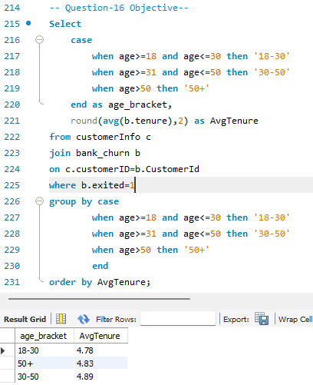

The scatter plot shows no strong direct correlation between estimated salary and account balance. Customers across all salary ranges exhibit similar balance distributions. Additionally, the relationship between salary and balance does not differ meaningfully between exited and retained customers, as both groups display overlapping and evenly dispersed patterns. This suggests that salary alone is not a key driver of balance levels or customer exit behavior.
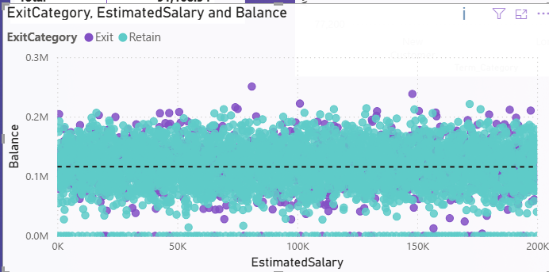

The scatter plot shows no meaningful correlation between estimated salary and credit score. Credit scores are widely distributed across all salary ranges, indicating that income level does not strongly influence creditworthiness. This pattern is consistent for both exited and retained customers.
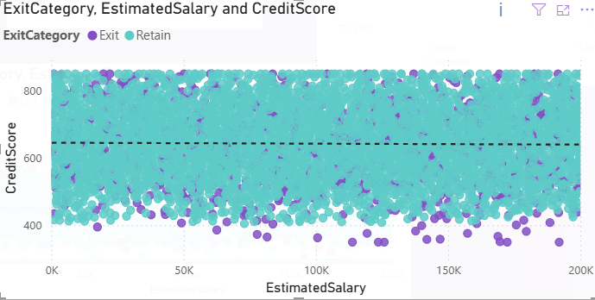

Credit score buckets were created to analyze churn distribution across different credit risk segments. The buckets were ranked based on the number of customers who have exited the bank. The analysis shows that lower credit score segments contribute a higher number of churned customers, while higher credit score segments have comparatively lower churn counts. This highlights credit score as an important factor influencing customer churn.
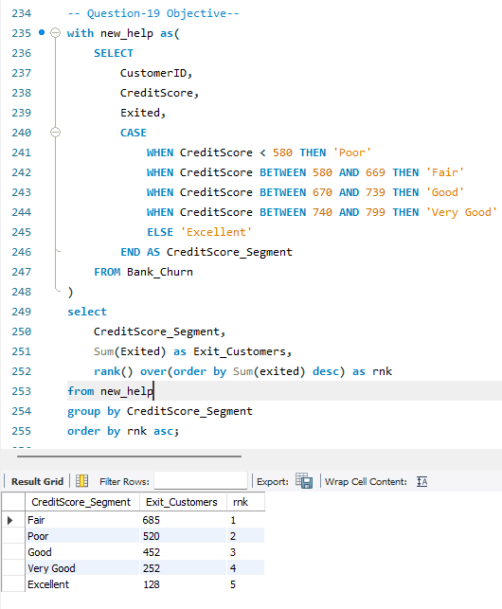

Customers were grouped into predefined age buckets, and the number of customers possessing a credit card was calculated for each group. The average number of credit cards across all age buckets was then computed. Age groups with a credit card count below this average were identified. The results indicate that certain age segments (18-30 and 50+) have lower credit card adoption, suggesting opportunities for targeted credit card marketing and awareness campaigns in these groups.
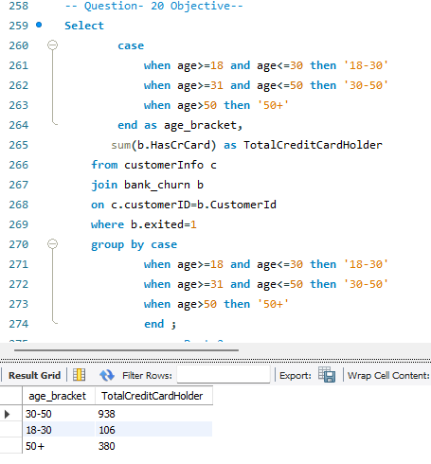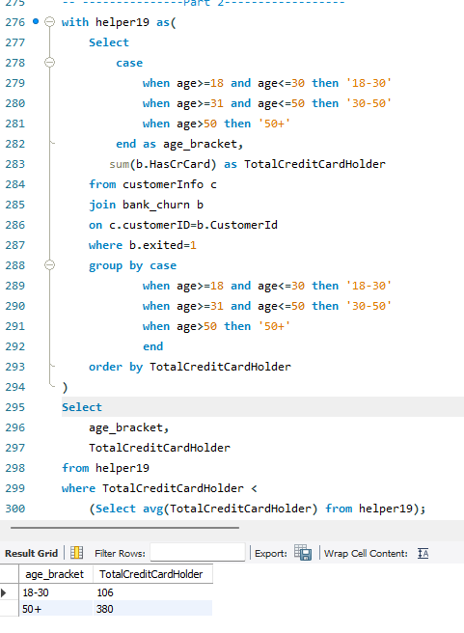

Locations were ranked based on the number of customers who have churned and the average account balance. The analysis shows that Germany experiences higher churn volumes while also holding significant average balances. Germany may require focused retention strategies to prevent loss of high-value customers and reduce overall churn impact.
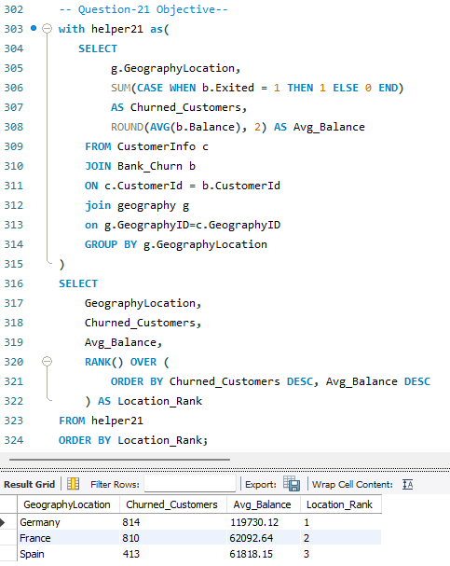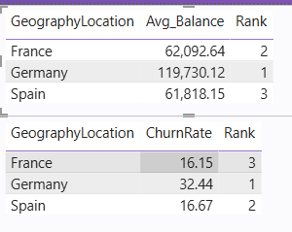

To enable joining with a table that uses a composite primary key consisting of CustomerId and Surname, a derived column can be created by concatenating these two fields using an underscore as a separator. This newly formed column follows the format CustomerId_Surname and can be effectively used as a composite join key in SQL joins.
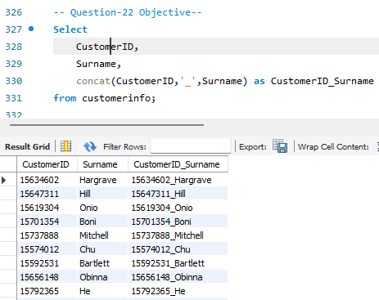

Yes, it is possible to retrieve the ExitCategory from the ExitCustomer table without using a JOIN. This was achieved using a correlated subquery that fetches the corresponding exit category based on the customer identifier.
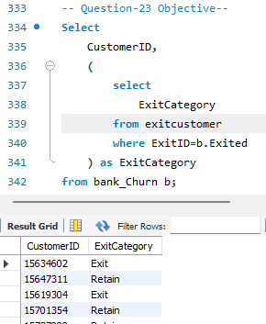

Missing values were checked using Power BI’s Power Query Editor through column profiling and data quality checks, and further validated using SQL queries. Based on the analysis, the dataset contained no missing values or entries that required handling. Power BI Power Query was used as the primary tool for data cleaning due to its transparency and reproducibility.

Missing values can be handled using various methods such as removing records with null values, replacing numeric fields with mean or median values, imputing categorical fields using mode, assigning default values for binary attributes, or applying forward and backward fill techniques in time-series data.
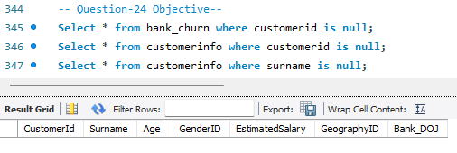

Customers whose surnames end with “on” were filtered using a pattern-matching condition. Their activity status was then retrieved by joining customer details with account activity information. The results display the customer identifier, surname, and whether the customer is currently active or not.
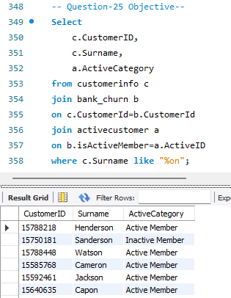

A data discrepancy was observed between the IsActiveMember and Exited columns. According to business logic, a customer who has exited the bank should not be marked as an active member. However, the dataset contains records where customers have Exited = 1 while still being marked as IsActiveMember = 1. Since the Exited column is confirmed to be accurate, this inconsistency indicates incorrect or outdated values in the IsActiveMember column. This discrepancy likely occurred due to delayed or incomplete status updates after customer exit and should be addressed during data cleaning or preprocessing. However it is not mentioned to make it change

Subjective Q’s Answers

a. Approach
To analyze customer behavior, customers were segmented based on tenure, which represents the length of the customer’s relationship with the bank. This segmentation allows a fair comparison of spending and engagement patterns over time.
Criteria used for segmentation:
- New Customers: Tenure ≤ 3 years
- Mid Term Customers: 3< Tenure ≤ 5
- Long-Term Customers: Tenure > 5 years
The analysis focused on the following quantitative indicators of spending behavior and engagement:
- Account Balance – indicates customer spending capacity and value
- Number of Products (NumOfProducts) – reflects product adoption and engagement
- Active Membership Status (IsActiveMember) – indicates ongoing relationship strength
Constraints
- The dataset does not contain transactional-level spending data; hence, account balance is used as a proxy for spending behavior.
- Customer behavior is analyzed at an aggregate level, not individually.
- Mid-term customers (tenure between 4–5 years) were excluded to ensure a clearer contrast between new and long-term customers.
References
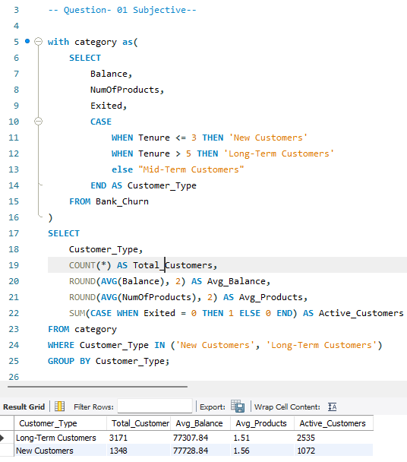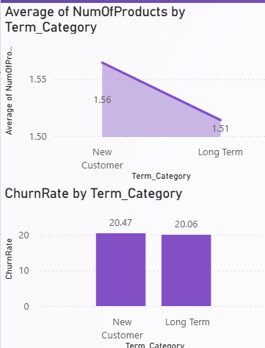
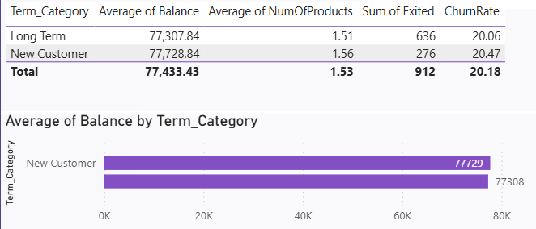
Insights Based on the Data
- New customers consistently show higher average account balances, indicating stronger financial engagement with the bank.
- They also use more banking products on average, suggesting higher product adoption and deeper integration with bank services.
- A higher proportion of long-term customers are marked as active members, reflecting sustained interaction and relationship stability.
- New customers tend to have:
  - Higher balances
  - Higher products
  - Lower engagement levels
These patterns indicate that customer engagement and spending behavior improve with tenure, as customers gain trust, familiarity, and reliance on the bank’s services over time.

Recommendations
Based on the observed patterns, the following actions are recommended:
- Implement structured onboarding programs for new customers to encourage early product adoption and active usage.
- Promote bundled products and personalized offers to new customers to accelerate engagement and increase switching costs.
- Introduce loyalty benefits, premium services, or exclusive rewards to retain high-value long-term customers.
- Use the number of products held by a customer as an early indicator of loyalty and churn risk.

Approach
The objective of this analysis is to identify product affinity, i.e., which banking products or services tend to be used together by customers. Product affinity helps understand customer needs and enables the bank to design effective cross-selling strategies.
The analysis focuses on:
- Number of products held by customers (NumOfProducts)
- Credit card ownership (HasCrCard)
- Customer activity status (IsActiveMember)
By analyzing how product counts vary across different customer segments (such as credit card holders and active customers), we can infer which services are commonly bundled together.
Criteria Used
- Customers were grouped based on:
  - Credit card ownership (HasCrCard = Yes / No)
  - Activity status (Active vs Inactive)
- Higher values of NumOfProducts were interpreted as stronger product affinity.
Constraints
- The dataset does not provide individual product-level details (e.g., savings account, loan, insurance).
- Product affinity is inferred from the number of products held, not from exact product combinations.
- The analysis assumes that a higher product count reflects usage of complementary banking services.

References
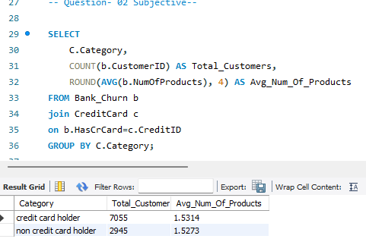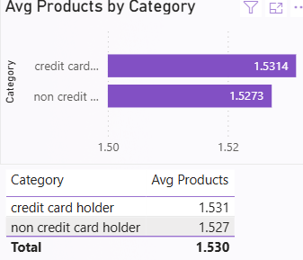
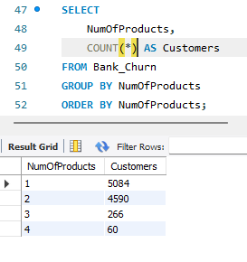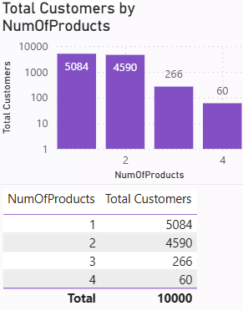
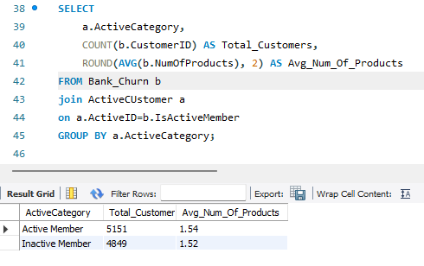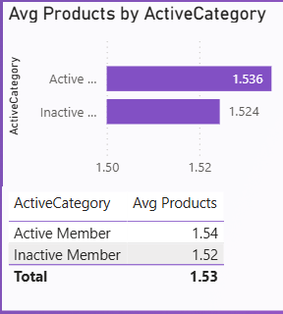
Insights Based on the Data
- Customers who own a credit card tend to hold a higher number of banking products, indicating strong product attraction.
- Active customers generally have more products compared to inactive customers, suggesting that engagement increases as customers adopt more services.
- Customers with multiple products are more deeply integrated into the bank’s ecosystem, making them less likely to switch.
- Single-product customers appear more vulnerable to churn due to lower dependency on the bank.
These insights suggest that certain products, such as credit cards, often act as gateway products, encouraging customers to adopt additional banking services.

Recommendations
- Customers who adopt credit cards should be targeted with offers for complementary products such as loans, savings plans, or investment services.
- Introduce bundled offerings (e.g., account + credit card + loan) to increase product adoption and customer stickiness.
- Identify customers holding only one product and design personalized campaigns to encourage additional product usage.
- Active customers already show higher engagement and are more receptive to cross-selling opportunities.

Approach
The objective of this analysis is to understand how geographic regions differ in terms of customer engagement and churn behavior, and how these differences may reflect regional economic conditions.
Since the dataset does not directly provide external economic indicators (such as GDP or employment rate), proxy indicators available within the data were used to represent regional economic behavior.
Key proxies used:
- Number of active customers (IsActiveMember) – indicator of customer engagement and economic stability
- Churn rate (Exited) – indicator of customer dissatisfaction or financial stress
- GeographyID – used to segment customers by region
The analysis compares regions based on:
- Proportion of active accounts
- Number of churned customers
- Overall customer distribution
Constraints
- External macroeconomic data (GDP, inflation, income index) is not available in the dataset.
- Geographic analysis is based solely on internal banking indicators.
- Regions are represented using encoded IDs rather than descriptive economic labels.

References
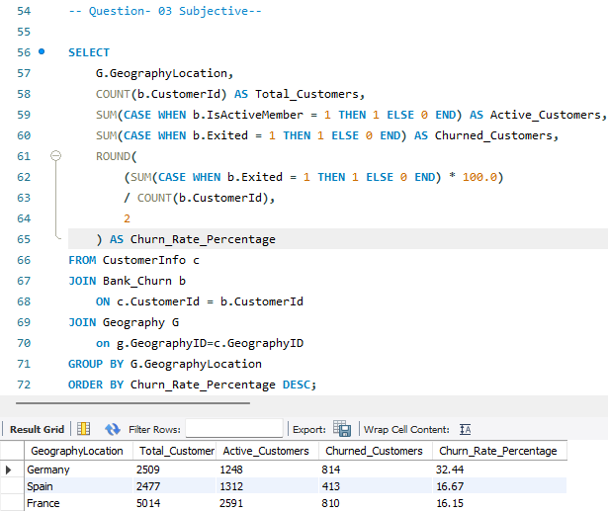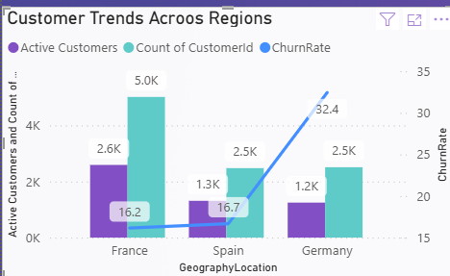
Insights Based on the Data
- France shows a higher concentration of active customers, indicating stronger customer engagement and possibly better economic stability.
- Other regions (Germany) exhibit higher churn rates, suggesting customer dissatisfaction, financial stress, or stronger competition.
- Regions with a higher proportion of active accounts generally show lower churn, implying a positive relationship between customer engagement and retention.
- The variation in customer behavior across regions highlights that geographic factors influence banking usage patterns, even in the absence of explicit economic indicators.
These trends suggest that regional economic conditions and customer expectations differ significantly across locations.

Recommendations
- Design customized retention programs for high-churn regions instead of applying uniform strategies across all geographies.
- Increase customer touchpoints, personalized offers, and financial advisory services in regions showing higher churn.
- Use regions with strong activity levels as benchmarks for best practices and successful engagement models.
- Enhancing the analysis with external economic indicators would provide deeper insights into regional performance and customer behavior.

a. Approach
The objective of this assessment is to identify high-risk customer segments by analyzing demographic and behavioral attributes that are commonly associated with financial risk and churn in banking.
Since direct risk indicators such as loan defaults or missed payments are not available, the analysis relies on proxy variables present in the dataset that indirectly reflect financial risk.
Key criteria used to assess risk:
- Credit Score – indicator of creditworthiness
- Age – reflects financial stability and lifecycle stage
- Tenure – length of relationship with the bank
- Number of Products (NumOfProducts) – engagement and dependency level
- Account Balance – financial value and stability
- Churn Status (Exited) – final indicator of risk materialization
Customers exhibiting low credit scores, short tenure, low product usage, and higher churn rates are considered higher-risk segments.
Constraints
- The dataset does not include loan default or repayment history.
- Risk assessment is based on historical customer behavior, not predictive modeling.
- Financial risk is inferred indirectly using churn and engagement-related attributes.

References
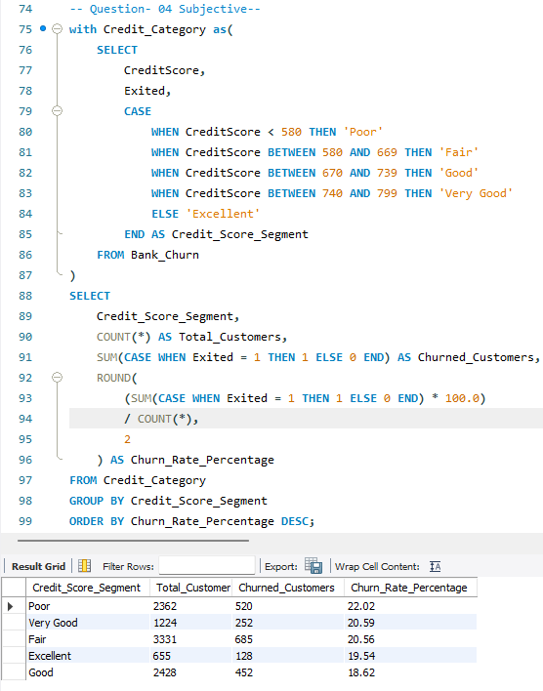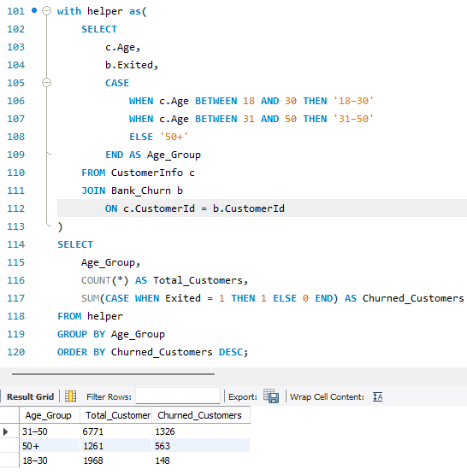
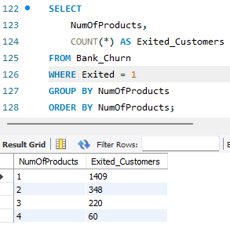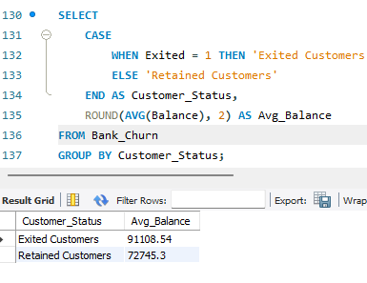
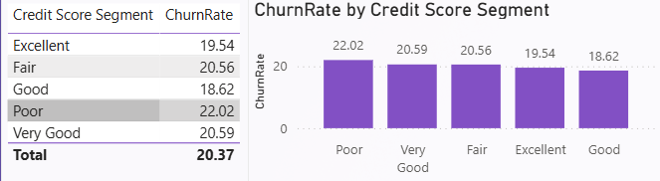
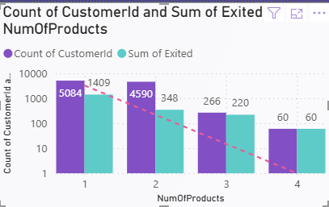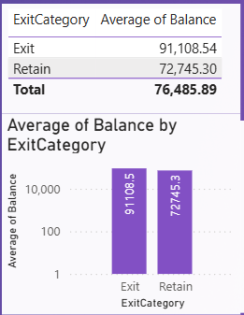
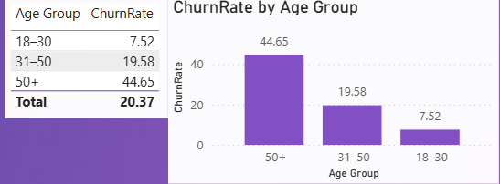
Insights Based on the Data
- Customers with lower credit scores consistently show higher churn rates, indicating weaker credit profiles and increased financial risk.
- Younger customers and customers with shorter tenure tend to exit earlier, suggesting lower relationship stability.
- Customers holding fewer banking products exhibit higher churn, indicating limited engagement and low switching costs.
- Customers with lower account balances are more likely to churn, reducing their long-term financial value to the bank.
- In contrast, customers with high credit scores, longer tenure, and multiple products show lower churn and pose lower financial risk.
Overall, the highest-risk demographic segment consists of:
- Low credit score customers
- Short-tenure customers
- Single-product users
- Lower balance holders

Recommendations
- Closely monitor customers with low credit scores and introduce early-warning indicators to prevent risk escalation.
- Implement onboarding and education programs for short-tenure customers to reduce early-stage churn.
- Encourage multi-product adoption among low-engagement customers to increase dependency and reduce risk.
- Design personalized retention and support strategies for customers identified as high-risk before churn occurs.

Approach
The objective of this analysis is to outline how customer lifetime (tenure) value can be estimated and forecasted using the available dataset. Customer lifetime value (CLV) represents the long-term value a customer brings to the bank over the duration of their relationship.
Since direct revenue and transaction-level profit data are not available, the approach relies on proxy indicators present in the dataset to approximate customer value and predict tenure longevity.
Key criteria used to estimate tenure value:
- Tenure – length of the customer’s relationship with the bank
- Account Balance – proxy for financial value
- Number of Products (NumOfProducts) – level of engagement and dependency
- Active Membership (IsActiveMember) – ongoing relationship strength
- Churn Status (Exited) – termination of lifetime value
Customers with longer tenure, higher balances, multiple products, and active status are considered to have higher predicted lifetime value.
Constraints
- The dataset does not contain revenue, transaction frequency, or profit margin data.
- Lifetime value is estimated using behavioral and engagement proxies, not exact monetary returns.
- The analysis is descriptive and strategic, not a predictive machine learning model.

References
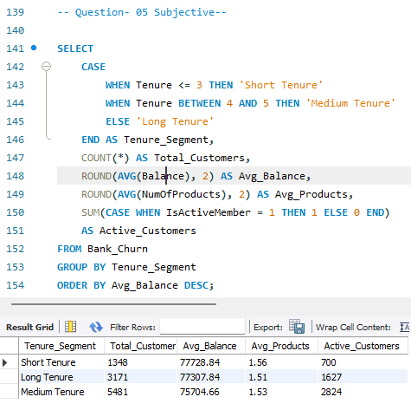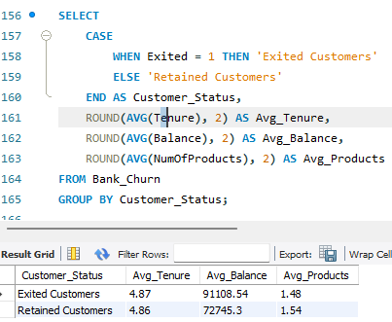
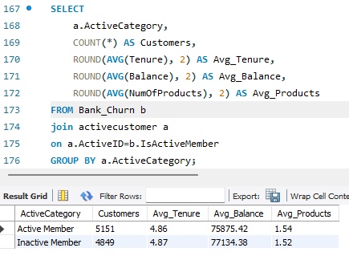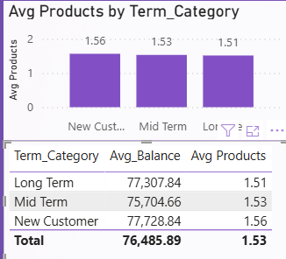
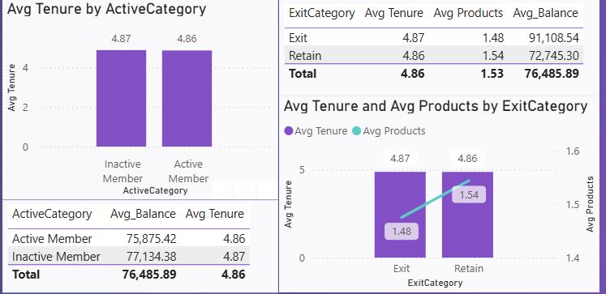
Insights Based on the Data
- Customers with shorter tenure consistently maintain higher average balances, indicating sustained financial value over time.
- Customers holding multiple products tend to remain with the bank longer, increasing their lifetime value.
- Active customers show stronger engagement and lower churn probability, making them more valuable in the long term.
- Customers with short tenure and limited product usage are more likely to churn early, resulting in lower lifetime value.
- Age also plays a role, as middle-aged and older customers often exhibit longer tenure and more stable banking behavior.
These insights suggest that lifetime value is closely tied to engagement depth, not just customer age or income.

Recommendations
- Classify customers into high, medium, and low lifetime value segments based on tenure, balance, and product usage.
- Provide personalized services, premium offerings, and loyalty benefits to customers with long tenure and high engagement.
- Focus on early-stage cross-selling and onboarding strategies to increase product adoption and reduce early churn.
- Monitor product count, active status, and balance trends as early indicators of future lifetime value.

Approach
The objective of this analysis is to evaluate how marketing campaigns influence customer acquisition and retention. In an ideal scenario, this would involve comparing customer behavior before and after campaign exposure.
Given the current dataset, campaign effectiveness can only be conceptually assessed using indirect indicators such as:
- Customer acquisition trends (via Bank DOJ)
- Customer retention and churn behavior
- Changes in engagement indicators (Tenure, IsActiveMember, NumOfProducts)
The approach would involve:
- Comparing customer joining trends during campaign periods versus non-campaign periods
- Analyzing churn rates and engagement levels among customers assumed to be influenced by marketing efforts
- Observing whether customers acquired during high-acquisition periods demonstrate better or worse retention
Constraints
- The dataset does not contain explicit marketing campaign data (e.g., campaign ID, campaign duration, exposure flag).
- There is no information on which customers were targeted or responded to campaigns.
- Attribution of customer behavior changes directly to marketing efforts is therefore not possible with certainty using the current data.

References
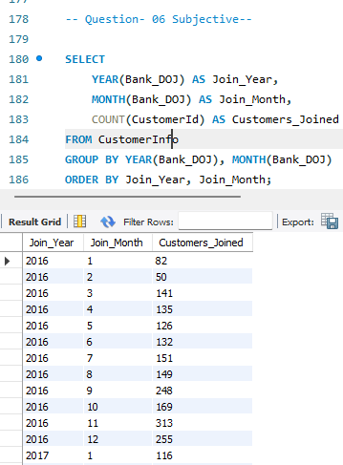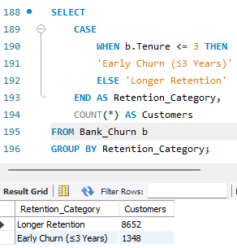
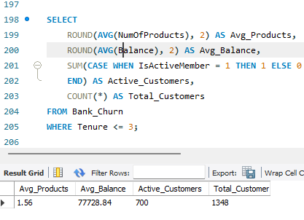
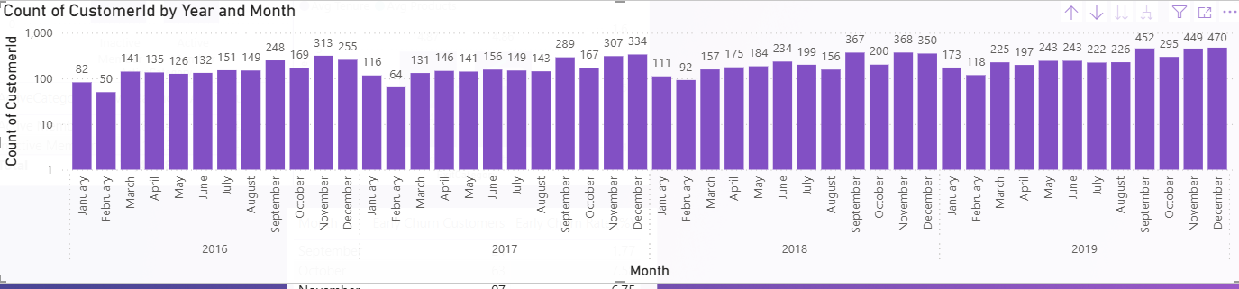
Insights Based on the Data
- Periods with higher customer acquisition (based on joining trends) may indicate the influence of marketing campaigns or promotional efforts.
- Customers with short tenure and early churn suggest that acquisition campaigns may be effective in attracting customers but less effective in retaining them.
- Customers who remain active and adopt multiple products after joining are more likely to have been successfully engaged through onboarding or marketing communication.
- Without explicit campaign data, observed acquisition spikes cannot be conclusively attributed to marketing effectiveness alone.
These observations suggest that while the dataset provides signals of acquisition and retention, it does not allow direct measurement of campaign success.

Recommendations
- Capture campaign-related attributes such as campaign ID, channel, duration, and target audience to enable direct effectiveness measurement.
- Add a flag indicating whether a customer was exposed to or responded to a campaign.
- Track engagement metrics (product adoption, balance growth, activity status) after campaign exposure to evaluate long-term impact.
- Analyze campaign effectiveness across demographics, geographies, and tenure groups to optimize targeting strategies.

a. Approach
The objective of this analysis is to identify common characteristics and behavioral patterns among customers who have exited the bank, in order to infer possible reasons for customer attrition.
Since the dataset does not explicitly capture customer exit reasons (such as service dissatisfaction or competitor switching), the analysis relies on observable proxy indicators available in the data.
Key criteria used to analyze exited customers:
- Credit Score – financial stability and creditworthiness
- Tenure – length of relationship before exit
- Number of Products (NumOfProducts) – engagement depth
- Account Balance – financial value and usage
- Active Membership Status (IsActiveMember) – engagement at the time of exit
- Demographic attributes (Age, GeographyID)
By comparing exited customers against retained customers across these dimensions, patterns explaining exit behavior can be inferred.
Constraints
- The dataset does not include explicit exit reasons or customer feedback.
- Behavioral trends are inferred from aggregated data, not individual exit narratives.
- External factors such as competition, pricing, or service quality are not captured.

References
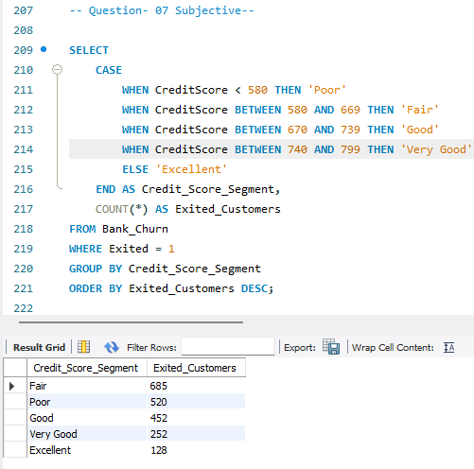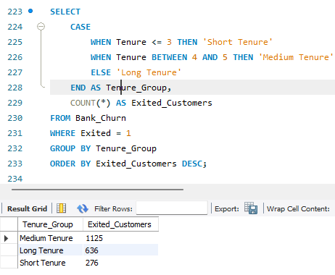
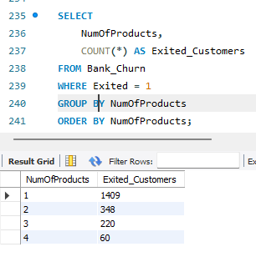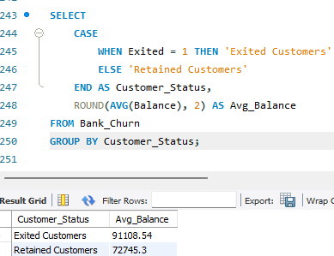

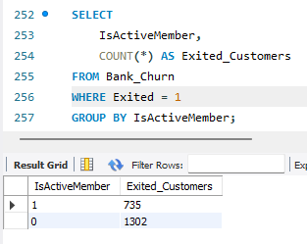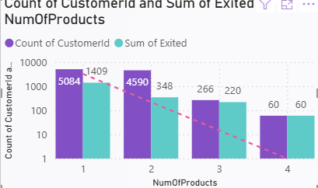
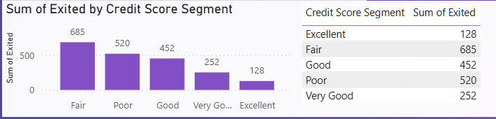
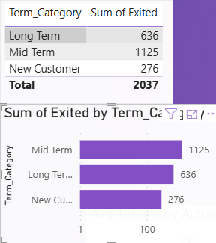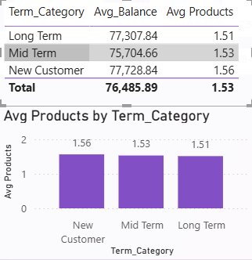
Insights Based on the Data
- A significant proportion of exited customers have lower credit scores, indicating higher financial risk and instability.
- Customers with Mid-term(4-5Years) tenure are more likely to exit, suggesting dissatisfaction or weak relationship formation over the lifecycle.
- Exited customers often hold fewer banking products, which reduces switching costs and increases the likelihood of churn.
- A noticeable number of exited customers are marked as inactive members, reflecting declining engagement prior to exit.
- Certain demographic segments, such as specific age groups or geographic regions, show higher concentrations of churn, suggesting location- or lifecycle-based influences.
These trends collectively point to low engagement, low financial value, and early-stage dissatisfaction as key contributors to customer exit.

Recommendations
- Monitor low product usage, declining balances, and inactivity as early indicators of potential exit.
- Focus on onboarding, personalized communication, and engagement strategies for short-tenure customers and regularly takes leads about services from customers.
- Encourage multi-product adoption to increase dependency and reduce churn likelihood.
- Design targeted retention strategies for customers with low credit scores or low engagement before they exit.

Approach
The objective of this analysis is to evaluate whether specific customer attributes can act as key predictors of customer churn. The focus is on four variables that represent relationship strength, engagement level, and financial capacity:
- Tenure – duration of the customer’s relationship with the bank
- NumOfProducts – depth of product engagement
- IsActiveMember – current level of customer interaction
- EstimatedSalary – customer income proxy
The approach involves examining how churn behavior varies across different levels of these variables and assessing whether consistent patterns emerge that indicate predictive power.
Rather than building a machine learning model, the analysis relies on behavioral trend evaluation, which is appropriate given the scope and nature of the dataset.
Constraints
- The dataset does not include labeled predictive features or model outputs.
- The analysis is descriptive, not algorithmic or probabilistic.
- External behavioral factors (customer satisfaction, competition, service quality) are not captured.
- Estimated salary represents income potential, not actual spending or profitability.

References
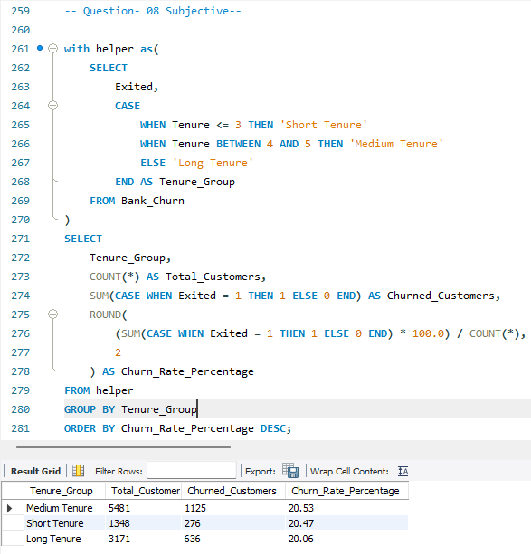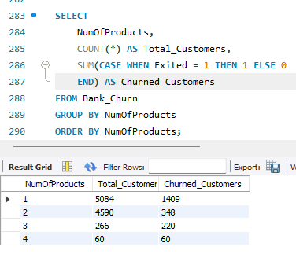
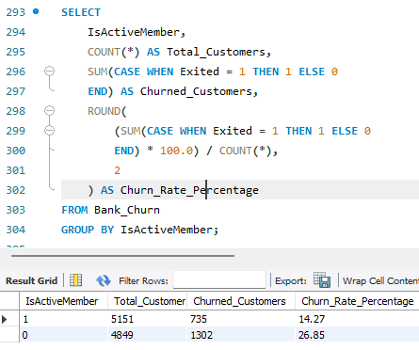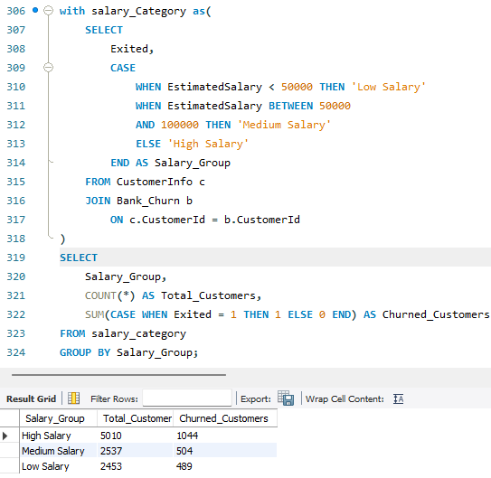
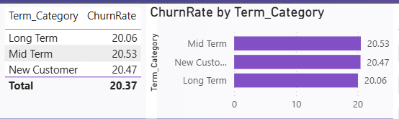
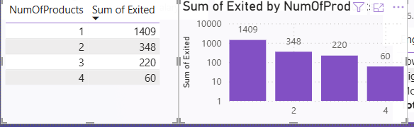
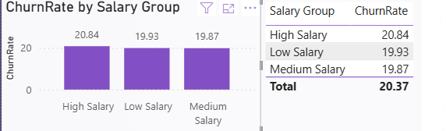
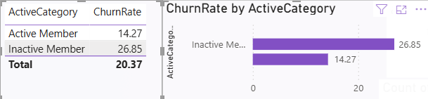
Insights Based on the Data
- Tenure is a strong predictor of churn: customers with shorter and mid tenure show a higher likelihood of exiting, indicating weaker relationship establishment.
- Number of Products has a significant inverse relationship with churn: customers holding fewer products are more likely to leave due to lower dependency on the bank.
- IsActiveMember is a critical behavioral indicator: inactive customers demonstrate substantially higher churn rates, suggesting disengagement before exit.
- EstimatedSalary shows a weaker and less consistent relationship with churn: higher income alone does not guarantee retention, as churn is more closely tied to engagement than earning potential.
Overall, engagement-related variables (Tenure, NumOfProducts, IsActiveMember) are stronger predictors of churn compared to purely financial attributes like estimated salary.

Recommendations
- Focus churn monitoring efforts on tenure, product usage, and activity status rather than income alone.
- Implement targeted engagement strategies for short-tenure customers to reduce early churn risk.
- Increase cross-selling initiatives to deepen customer dependency and reduce churn likelihood.
- Combine estimated salary with engagement metrics rather than relying on it independently for churn prediction.

Approach
The objective of this analysis is to design a customer segmentation framework using demographic attributes and account-related details available in the dataset. Customer segmentation helps the bank better understand its customer base, tailor products, and design targeted strategies.
The segmentation is conceptually implemented using SQL-based grouping and conditional logic, leveraging both customer profile and account behavior data.
Key segmentation dimensions used:
Demographic-based criteria:
- Age – customer lifecycle stage
- GenderID – demographic differentiation
- GeographyID – regional segmentation
Account-based criteria:
- Tenure – relationship duration
- Balance – financial value proxy
- NumOfProducts – engagement depth
- IsActiveMember – activity status
- HasCrCard – service adoption indicator
By combining these attributes, customers can be segmented into meaningful groups such as:
- Young vs senior customers
- High-value vs low-value customers
- Highly engaged vs low-engagement customers
Constraints
- The dataset does not include behavioral or psychographic attributes.
- Demographics are limited to age, gender, and geography.
- Segmentation is rule-based (SQL-driven), not machine-learning-based.
- Customer behavior is evaluated at a snapshot level, not longitudinally.

References
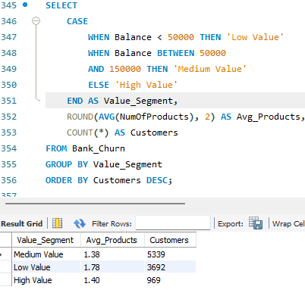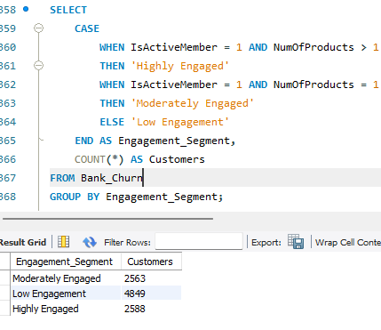
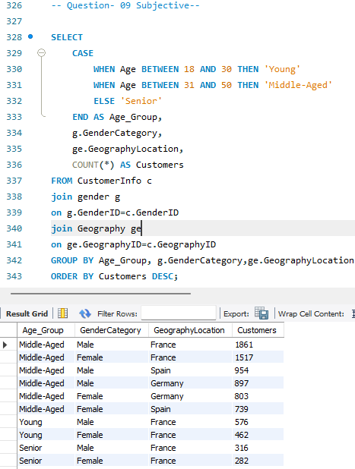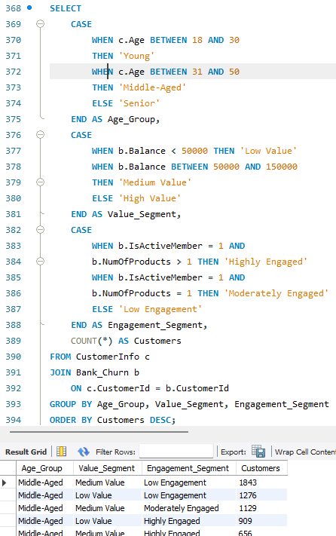
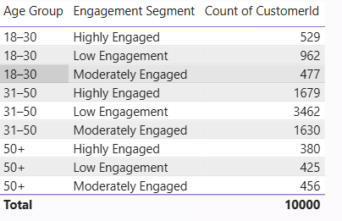
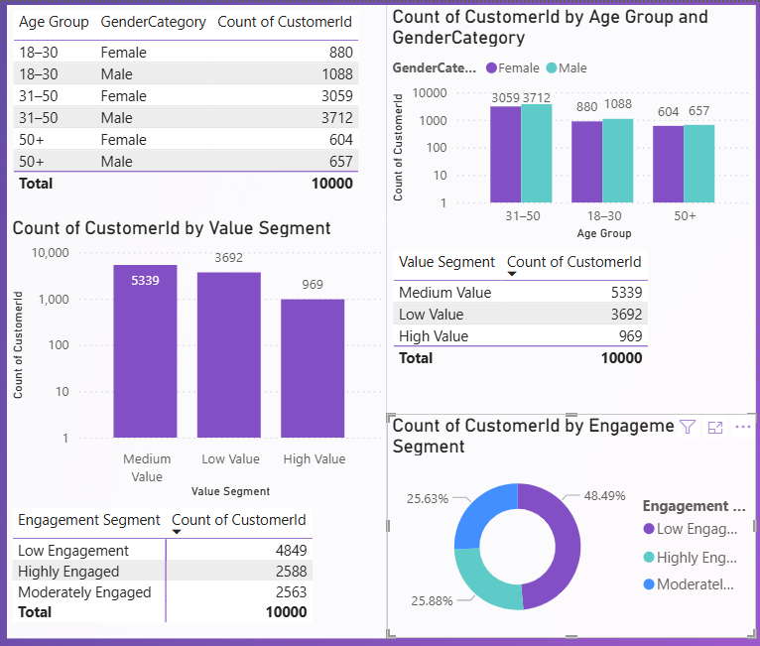
Insights Based on the Data
- Customers can be clearly segmented into distinct demographic groups, each exhibiting different engagement and value characteristics.
- Younger customers and Low value or Medium value customers often fall into lower engagement segments, indicating early-stage relationships.
- Customers with higher balances and multiple products form a high-value segment with stronger engagement and lower churn tendencies.
- Inactive customers with low product usage represent a high-risk segment requiring targeted retention strategies.
- Geographic segmentation reveals that customer behavior and engagement vary across regions, supporting the need for location-specific strategies.
These insights demonstrate that combining demographic and account-level attributes creates actionable customer segments that support strategic decision-making.

Recommendations
- Combine demographic and account-level attributes rather than relying on a single criterion for segmentation.
- Develop customized marketing, retention, and cross-selling strategies for each customer segment.
- Allocate more resources toward customers with high balances, long tenure, and strong engagement.
- Update segmentation logic periodically to reflect changes in customer behavior over time.

Approach
The objective of this analysis is to design a visual decision-support mechanism using conditional formatting to:
- Identify customers at high risk of churn
- Evaluate whether credit card ownership (and related rewards) positively influences customer retention
Conditional formatting does not change the data itself; instead, it enhances interpretability by visually emphasizing critical patterns and risk indicators in dashboards and reports.
To identify churn risk and retention impact, the following proxy indicators from the dataset are used:
Churn risk indicators:
- Exited – confirms churn outcome
- IsActiveMember – disengagement signal
- Tenure – early-stage customers are more vulnerable
- NumOfProducts – low product usage indicates weak attachment
- Balance – lower balances often correlate with churn
Credit card retention indicators:
- HasCrCard – identifies customers eligible for card-related rewards
- Churn Rate by HasCrCard – evaluates retention differences
Conditional formatting is applied to tables, matrices, and KPIs to:
- Highlight high-risk customers
- Visually compare credit card holders vs non-holders
Constraints
- The dataset does not contain explicit credit card reward usage or reward value data.
- Credit card impact is inferred from ownership, not reward redemption behavior.
- Conditional formatting provides visual prioritization, not predictive certainty.

References
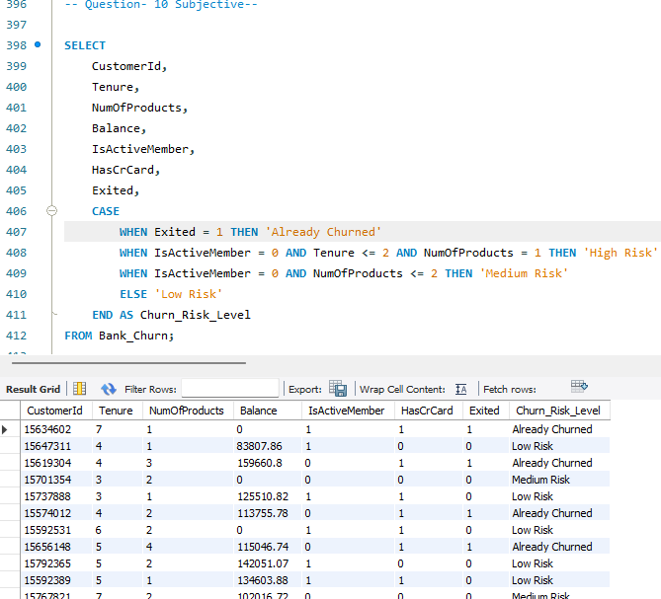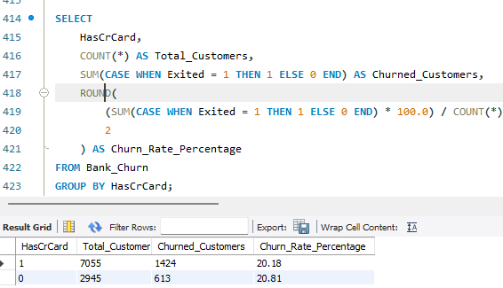
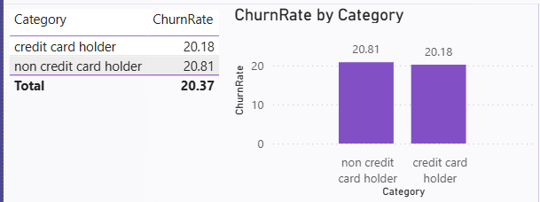
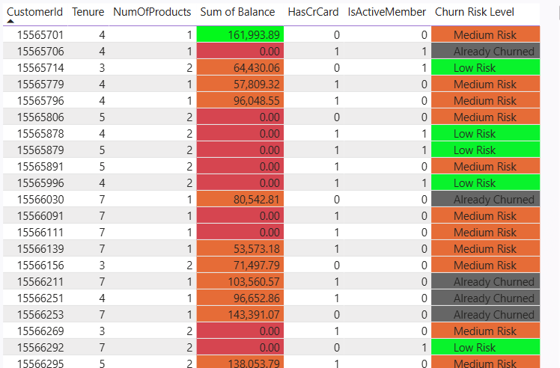
Insights Based on the Data
- Customers with low tenure, low product usage, inactive status, and lower balances consistently appear as high-risk churn segments.
- Conditional formatting allows these customers to be instantly identified in reports through color coding (e.g., red or amber highlights).
- Customers who own credit cards tend to show better retention behavior, suggesting that credit card benefits and rewards may contribute to stronger engagement.
- Visual comparison between credit card holders and non-holders highlights that non-card customers are more frequently present in high-risk churn categories.
Overall, conditional formatting transforms complex churn indicators into intuitive visual signals, enabling faster and more informed decision-making.

Recommendations
- Use conditional formatting to flag customers with low tenure, inactivity, low balances, and single-product usage as high-risk.
- Visually differentiate credit card holders and non-holders to assess the retention impact of card-related benefits.
- Equip relationship managers and analysts with visually prioritized customer lists to intervene before churn occurs.
- Incorporate reward usage and redemption metrics to directly measure the effectiveness of credit card rewards on retention.

Approach
The objective of this analysis is twofold:
- Quantify churn at both:
  - An overall level (entire dataset)
  - A year-wise level, to understand churn trends over time
- Interpret churn patterns to identify customer segments more prone to exiting and recommend actionable strategies to reduce churn.
Churn Definition Used:
- A customer is considered churned if Exited = 1.
Time Dimension Used:
- Bank DOJ (Date of Joining) is used to derive yearly cohorts of customers.
- Year-wise churn is analyzed by grouping customers based on the year associated with their banking relationship.
Customer characteristics analyzed to explain churn:
- Tenure
- Number of products
- Activity status
- Credit score
- Balance
- Credit card ownership
- Demographics (Age, Geography)
This structured approach ensures that churn is measured consistently and insights are derived from observable behavioral patterns.
Constraints
- The dataset does not contain an explicit “exit date”; churn timing is inferred from customer cohorts.
- Churn is analyzed at an aggregate level, not as a real-time churn rate.
- External factors (market conditions, competitors, service quality) are not captured.
- Year-wise churn trends depend on the distribution of customers across joining years.

References
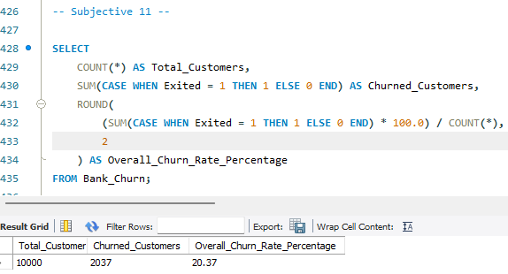
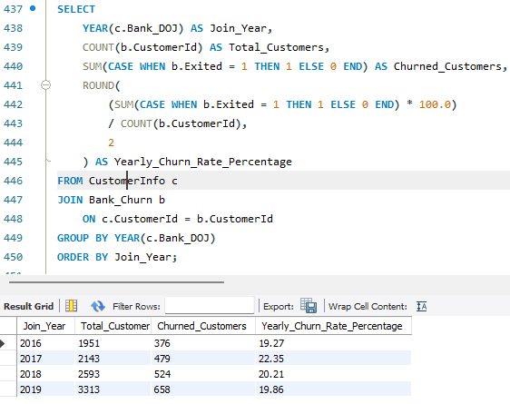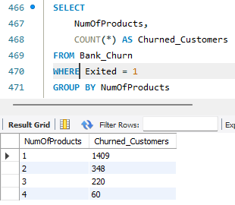
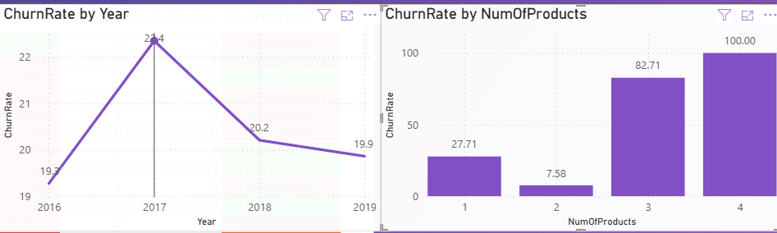
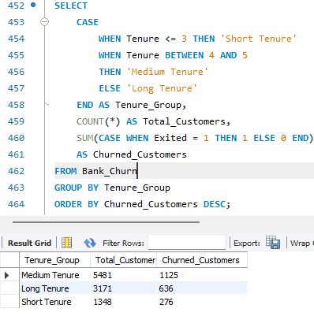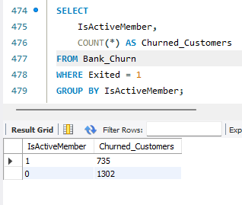
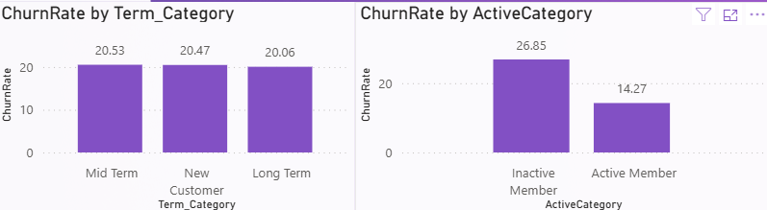
Insights Based on the Data
Overall and Year-wise Churn Patterns
- The overall churn rate provides a baseline understanding of customer attrition across the bank.
- Year-wise churn analysis reveals fluctuations in churn, highlighting periods of higher customer exits that may correspond to changes in business strategy, market competition, or customer acquisition quality.
- Certain years may show higher churn due to a higher proportion of short-tenure or low-engagement customers.

Customer Segments More Likely to Churn
Based on behavioral and demographic trends:
- Short and Mid-tenure customers are more likely to churn, indicating weak early relationship formation.
- Customers with low product usage (one or two products) exhibit higher churn due to lower dependency on the bank.
- Inactive customers show significantly higher churn, suggesting disengagement prior to exit.
- Customers with lower credit scores and lower balances are more prone to churn.
- Customers without credit cards tend to churn more than those with credit card relationships, indicating weaker engagement.
Overall, churn is driven more by engagement and relationship strength than by income alone.

Recommendations
- Strengthen onboarding, communication, and engagement for newly acquired customers to reduce early churn.
- Encourage multi-product adoption through personalized cross-selling to increase switching costs.
- Use activity status as an early warning signal and intervene before churn occurs.
- Promote credit card adoption and associated benefits to deepen customer relationships and improve retention.
- Use year-wise churn trends to identify high-risk periods and adjust retention campaigns accordingly.

A comprehensive Power BI dashboard was created to consolidate all key performance indicators and visualization-based metrics related to customer churn, engagement, and retention.
To enhance interactivity, slicers were incorporated to allow dynamic filtering by attributes such as geography, gender, tenure group, and credit card ownership. This enables users to drill down into specific customer segments and perform targeted analysis. The dashboard provides a centralized and intuitive platform for monitoring customer behavior and supporting strategic decision-making.
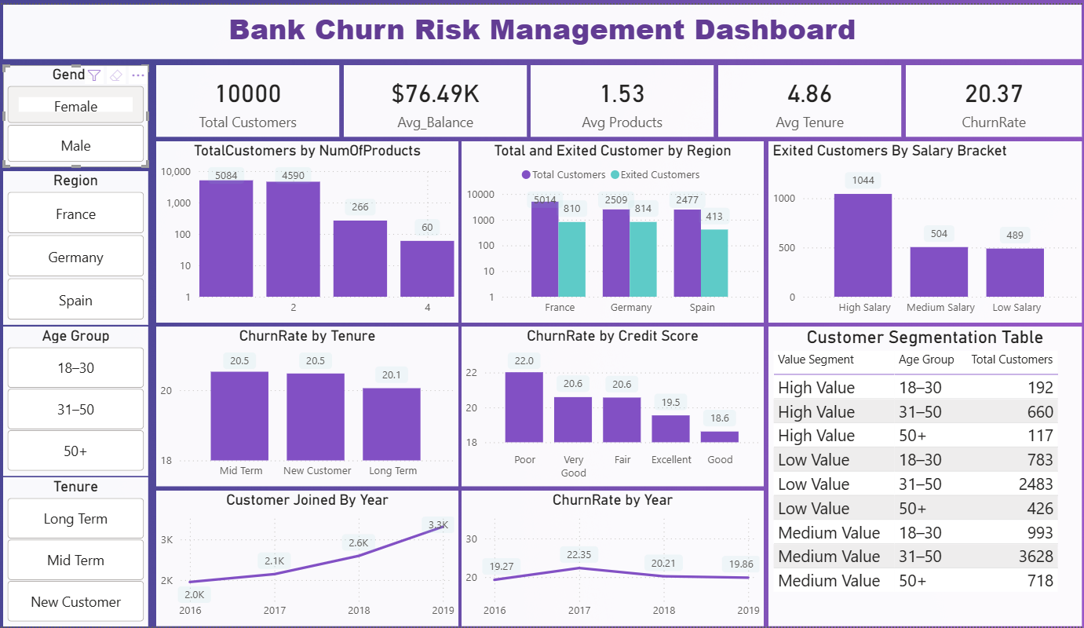

If no predefined objective or subjective questions were given, the problem would be approached using a standard end-to-end data analytics framework, focusing on deriving insights that align with business goals, particularly customer retention and value optimization.
The approach would follow these structured phases:
- Business Understanding
  - Identify the core business problem (e.g., customer churn, retention, profitability).
  - Define success metrics such as churn rate, customer lifetime value, and engagement levels.
- Data Understanding & Exploration
  - Review available tables and understand relationships between customer demographics and account behavior.
  - Perform exploratory data analysis to understand distributions, trends, and anomalies.
- Key Metric Identification
  - Identify critical KPIs such as churn rate, active customers, product usage, tenure, and balance.
  - Segment customers to uncover behavioral patterns.
- Insight Generation
  - Analyze customer lifecycle stages.
  - Identify churn drivers, high-value segments, and engagement gaps.
- Actionable Recommendation Design
  - Translate insights into practical strategies for retention, cross-selling, and risk mitigation.
This approach ensures that insights are data-driven, business-relevant, and scalable, even without predefined questions.

The column name HasCrCard in the Bank_Churn table can be modified using either the database layer or the reporting layer. At the database level, the column was renamed using the ALTER TABLE statement in MySQL, ensuring schema-level consistency across all dependent systems. Alternatively, Power BI’s Power Query Editor can be used to rename the column within the reporting environment without affecting the underlying database. This approach is useful when database access is restricted or when changes are required only for visualization and reporting purposes.
